GIATA Data Extraction
How-To Guide to GIATA data extraction script files

Overview

As part of our relationship with matched hotel data provider GIATA of Germany, we have created the included helper scripts. Basically they allow you to extract the data from their API, into 2x easier to use csv files that you can import into a Relational Database for easier local usage.
The scripts are given to you “AS IS”, we make no claims of performance, and all other legal disclaimers apply here. Our intention is to help our many partners consume the GIATA information in a manner similar to our own downloadable data files. GIATA does NOT support the following scripts, they are aware of our distribution, and EAN try to keep it up to date of changes to the GIATA API and/or underlying data structure.
The database engine and creation script utilize 100% open source software, so you can download all the required files without cost. Putting them in a production environment is a different story. Read the boring licenses of each product like if your live depends on it!

Importing the Data

Import Scripts
The application scripts are written in the Python language, we choose Python as it available in most platforms, its modern and sound powerful when you mention it!
Some additional modules are required, we will explain the requirements as we progress.

Configuring Python

Using the Data in a DB

MySQL
First you need the MySQL Database engine, go to: http://dev.mysql.com/
On the download section select the Community Server Edition, or better yet the single all-in-one download from the banner like this:
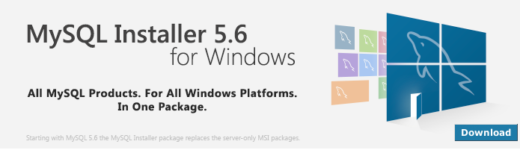
You can avoid registration by clicking on the No thanks, just start my download. The single shoot download is about 176MB. Install it, the Developer Package will suite our needs.
You will have the nice opportunity to add an extra user, I always create the user: eanuser, password: Passw@rd1 for testing, but choose your own.
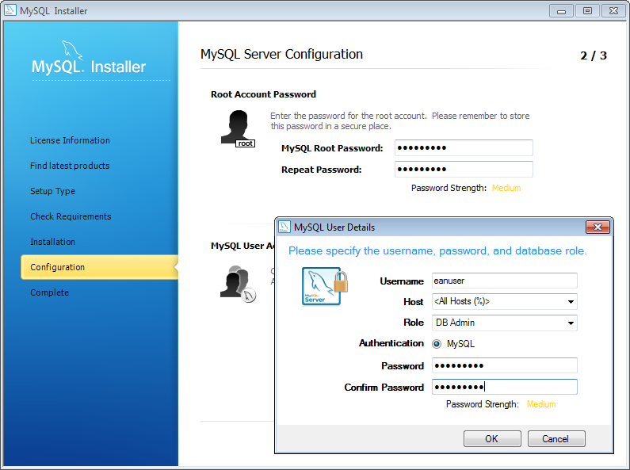

Configure the MySQL Engine

Configure the database of MySQL just consist of changing the my.cnf file. We need this to include UTF-8 support and proper sorting (choose the one you need for your character set).

Create the Database

Run the MySQL Workbench utility, connect to the MySQL Server, you will need to connect as the database “root” user and open the script called:
MySQL_create_eanmap.sql
And run it (press the yellow bolt). It should generate the tables, you may see some warnings but that is fine (script will erase a previous database structure if exist).

